**1)Install nginx and run nginx on port number 81.**

**2) Deploy a sample index.html file on nginx.**

**3) Install Apache and run Apache on port number 82**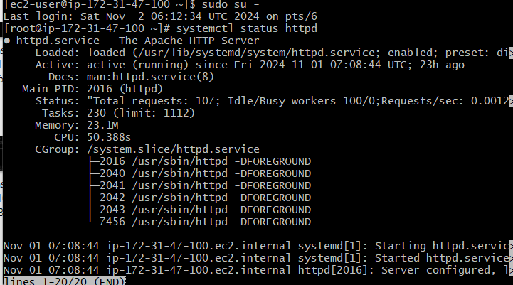

**4) Deploy a sample index.html file on Apache**

**5) Install Apache tomcat on port number 8082**

**6) Deploy a sample app on webapps**

**7) Create a tomcat.service file for tomcat**

**8) Configure HA Proxy server**